<Vehicle Make>
<Vehicle Model>
<Vehicle Year>

<Client Name>
<Client Address>
<Project Name>
<Phone Number>
<Your Contact Name>
<Address>
<Phone>
<Email>

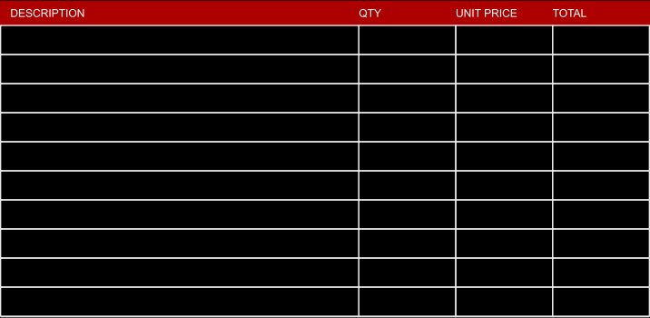
$
0. 00

-
-
$
0. 00

-
-
$
0. 00

-
-
$
0. 00

-
-
$
0. 00

-
-
$
0. 00

-
-
$
0. 00

-
-
$
0. 00

-
-
$
0. 00

-
-
$
0. 00

-
-
0. 00

0. 00

$
$
0. 00

$
0. 00

0. 00

0. 00

0. 00

0. 00

0. 00

0. 00

$
$
$
$
$
$
$

$0. 00

$0. 00

$0. 00

0. 00%

$0. 00

$0. 00

$0. 00

