
INVOICE
Design Studio Pro

#123456

3/3/25

3/3/25

<Client Name>
<Client Address>
<Project Name>
<Address>
<Phone>
<Email>
<Your Contact Name>
<Address>
<Phone>
<Email>

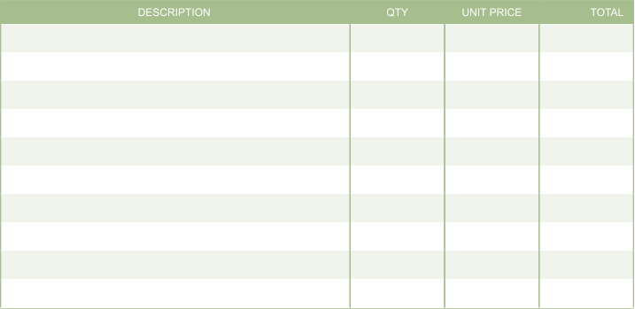
-
$
0. 00

-
-
$
0. 00

-
-
$
0. 00

-
-
$
0. 00

-
-
$
0. 00

-
-
$
0. 00

-
-
$
0. 00

-
-
$
0. 00

-
-
$
0. 00

-
-
-
$
0. 00

$
$
$
$
$
$
$
$
$
$
0. 00

0. 00

0. 00

0. 00

0. 00

0. 00

0. 00

0. 00

0. 00

0. 00

$
0. 00

0. 00

$
0. 00

$
0. 00%

0. 00

$
0. 00

$


0. 00

$

